Epoch 1/50

1682/1682 [==============================] - ETA: 0s - loss: 890.5716 - accuracy: 0.62192024-03-12 17:47:36.372672: W tensorflow/tsl/framework/cpu_allocator_impl.cc:83] Allocation of 21018624000 exceeds 10% of free system memory.

2024-03-12 17:49:21.919502: W tensorflow/tsl/framework/cpu_allocator_impl.cc:83] Allocation of 21018624000 exceeds 10% of free system memory.

2024-03-12 17:49:36.820422: W tensorflow/tsl/framework/cpu_allocator_impl.cc:83] Allocation of 42037248000 exceeds 10% of free system memory.

2024-03-12 17:54:46.602713: W tensorflow/tsl/framework/cpu_allocator_impl.cc:83] Allocation of 2463498240 exceeds 10% of free system memory.

2024-03-12 17:54:47.540233: W tensorflow/tsl/framework/cpu_allocator_impl.cc:83] Allocation of 2463498240 exceeds 10% of free system memory.

1682/1682 [==============================] - 4128s 2s/step - loss: 890.5716 - accuracy: 0.6219 - val_loss: 689.2926 - val_accuracy: 0.6904 - lr: 1.0000e-04

Epoch 2/50

1682/1682 [==============================] - 3894s 2s/step - loss: 562.4069 - accuracy: 0.7241 - val_loss: 662.7576 - val_accuracy: 0.7057 - lr: 1.0000e-04

Epoch 3/50

1682/1682 [==============================] - 4081s 2s/step - loss: 328.1101 - accuracy: 0.8167 - val_loss: 760.1228 - val_accuracy: 0.6985 - lr: 1.0000e-04

Epoch 4/50

1682/1682 [==============================] - 3964s 2s/step - loss: 128.6697 - accuracy: 0.9123 - val_loss: 1040.3159 - val_accuracy: 0.6884 - lr: 1.0000e-04

Epoch 5/50

1682/1682 [==============================] - 3813s 2s/step - loss: 64.8080 - accuracy: 0.9716 - val_loss: 1380.7050 - val_accuracy: 0.6710 - lr: 1.0000e-04

Epoch 6/50

1682/1682 [==============================] - 3831s 2s/step - loss: 43.1657 - accuracy: 0.9866 - val_loss: 1579.2365 - val_accuracy: 0.6714 - lr: 1.0000e-04

Epoch 7/50

1682/1682 [==============================] - ETA: 0s - loss: 27.0642 - accuracy: 0.9900

Epoch 7: ReduceLROnPlateau reducing learning rate to 5.999999848427251e-05.

1682/1682 [==============================] - 3954s 2s/step - loss: 27.0642 - accuracy: 0.9900 - val_loss: 1582.8118 - val_accuracy: 0.6672 - lr: 1.0000e-04

2883/2883 [==============================] - 49s 17ms/step

Evaluation Metrics:

Precision: 0.6397

Recall: 0.9433

F1 Score: 0.7624

ROC AUC: 0.8290

PR AUC: 0.8471

MCC: 0.4682

y_pred = (test_scores > 0.6).astype(int)

...: y_true = y_test.astype(int)

...:

...: # Calculate evaluation metrics

...: precision = precision_score(y_true, y_pred)

...: recall = recall_score(y_true, y_pred)

...: f1 = f1_score(y_true, y_pred)

...: roc_auc = roc_auc_score(y_true, test_scores)

...: pr_auc = average_precision_score(y_true, test_scores)

...: mcc = matthews_corrcoef(y_true, y_pred)

...:

...: # Confusion Matrix

...: conf_matrix = confusion_matrix(y_true, y_pred)

...:

...: # Display evaluation metrics

...: print("\nEvaluation Metrics:")

...: print(f'Precision: {precision:.4f}')

...: print(f'Recall: {recall:.4f}')

...: print(f'F1 Score: {f1:.4f}')

...: print(f'ROC AUC: {roc_auc:.4f}')

...: print(f'PR AUC: {pr_auc:.4f}')

...: print(f'MCC: {mcc:.4f}')

...:

Evaluation Metrics:

Precision: 0.8915

Recall: 0.5013

F1 Score: 0.6417

ROC AUC: 0.8290

PR AUC: 0.8471

MCC: 0.4897

In [11]: y_pred = (test_scores > 0.7).astype(int)

...: y_true = y_test.astype(int)

...:

...: # Calculate evaluation metrics

...: precision = precision_score(y_true, y_pred)

...: recall = recall_score(y_true, y_pred)

...: f1 = f1_score(y_true, y_pred)

...: roc_auc = roc_auc_score(y_true, test_scores)

...: pr_auc = average_precision_score(y_true, test_scores)

...: mcc = matthews_corrcoef(y_true, y_pred)

...:

...: # Confusion Matrix

...: conf_matrix = confusion_matrix(y_true, y_pred)

...:

...: # Display evaluation metrics

...: print("\nEvaluation Metrics:")

...: print(f'Precision: {precision:.4f}')

...: print(f'Recall: {recall:.4f}')

...: print(f'F1 Score: {f1:.4f}')

...: print(f'ROC AUC: {roc_auc:.4f}')

...: print(f'PR AUC: {pr_auc:.4f}')

...: print(f'MCC: {mcc:.4f}')

...:

Evaluation Metrics:

Precision: 0.9614

Recall: 0.4374

F1 Score: 0.6013

ROC AUC: 0.8290

PR AUC: 0.8471

MCC: 0.5008

Εικόνα που περιέχει κείμενο, στιγμιότυπο οθόνης, πολυχρωμία, διάγραμμα

Περιγραφή που δημιουργήθηκε αυτόματα

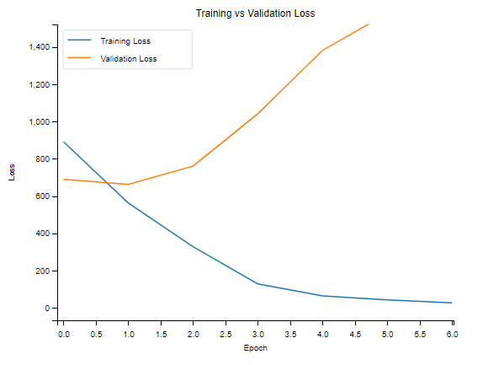

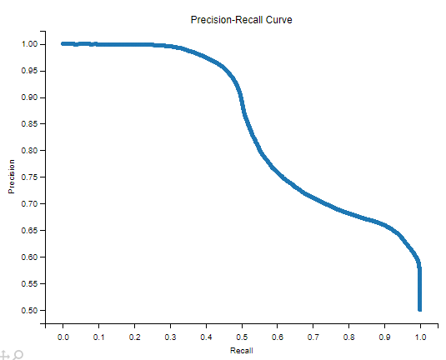

Εικόνα που περιέχει κείμενο, στιγμιότυπο οθόνης, διάγραμμα, ορθογώνιο παραλληλόγραμμο

Περιγραφή που δημιουργήθηκε αυτόματα

Εικόνα που περιέχει κείμενο, γράφημα, γραμμή, διάγραμμα

Περιγραφή που δημιουργήθηκε αυτόματα